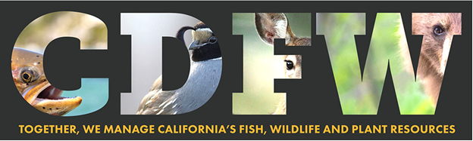

Nature Bowl 2023: Coach Registration Form

Welcome to the California Department of Fish and Wildlife’s Nature Bowl 2023! We are very excited to have you and your team participate this year in the fun and educational Nature Bowl competition!

Please fill out this form completely, then email it to: genelle.treaster@wildlife.ca.gov
There is a $25 per team registration fee. Payment details forthcoming. Thank you!

COACH NAME:
SCHOOL:
SCHOOL ADDRESS:
COACH EMAIL ADDRESS:
COACH PHONE NUMBER:
TEAM GRADES: 3/4 grade (or) 5/6 grade

PREFERRED SEMI-FINAL SITE AND DATE (please rank 1, 2, 3):
March
___ 15 Nimbus Fish Hatchery
___ 22 Sutter/Yuba County
___ 29 Placer Nature Center

April
___ 13 American River Conservancy
___ 18 Calaveras/Tuolumne
___ 20 Stone Lakes National Wildlife Refuge
___ 26 Yolo Basin

